Plan no P1

This is a type of typing work and this is very simple.

This type of pages we provides for typing.

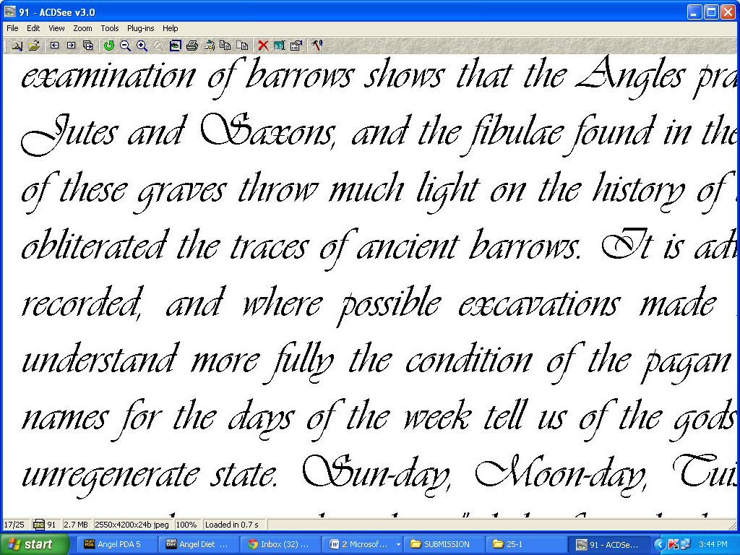

You will simply type the contant in the notepad like this.

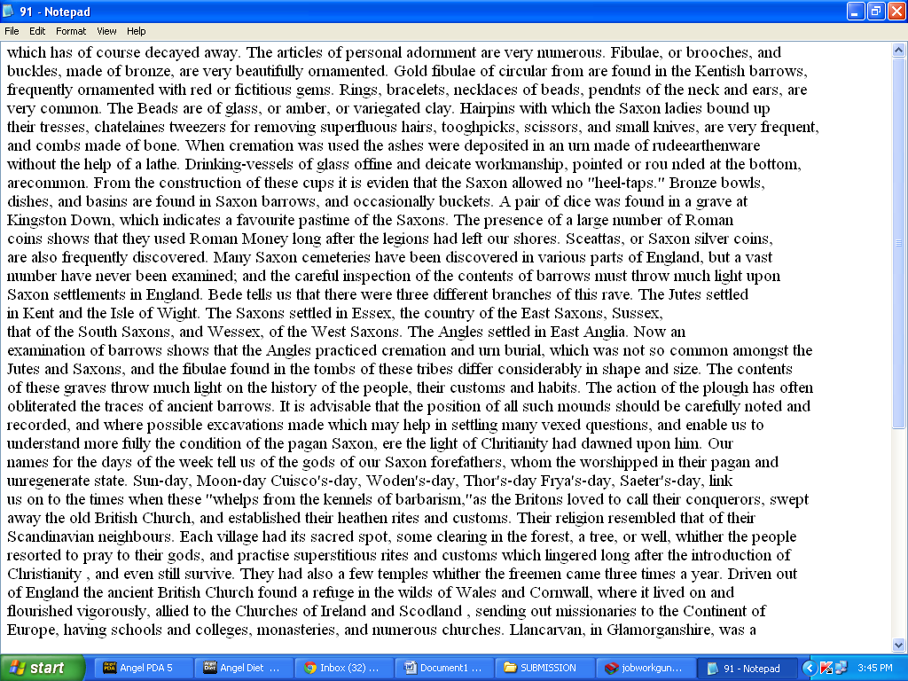

You will open both file on your pc screen this way for typing.

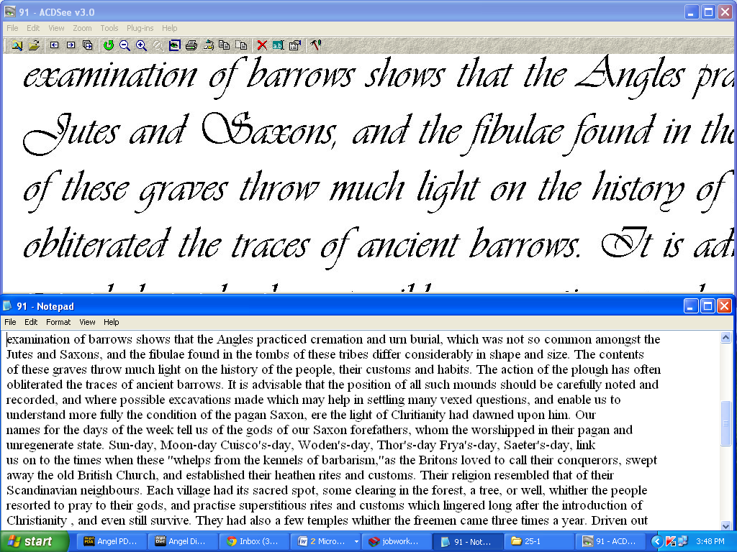

**This is very simple work you can complete it from home.**

## About this work

|  |  |
| --- | --- |
| **Refundable Security** | **Rs 1600/- (Refundable on successfull completion of first lot)** |
| **Total Pages** | **25** |
| **Time limit** | **4 days (including holiday)** |
| **Payment** | **Rs 160/- (Per Page)** |
| **Total Payment** | **Rs 4000/-** |

**Note:You will get this work 3- 4 times in a month on regular basis, if you want to leave or take a break in between, you can.**

**Some Important thing to know –**

* **You will get work through mail and you will also submit work through mail.**
* **You will send me only soft copy of output files.**
* **You will get your accuracy report and payment within 24 hours after submission of your work.**
* **You will get your payment directly into your bank account or through cheque within 24 hours after the work submission.**
* **Plan once choosen can be changed later.**

**ACCURACY PARAMETER FOR JPG TO DOC**

**The party accepts the accuracy and payments very clearly IMAGE TO NOTEPAD Project.**

**The accuracy should be ABOVE 60%.**

**Accuracy Charges**

**50%- 100% = Rs 160/- ( Rs 160/- Per Page)**

**PLAN P 2:**

|  |  |
| --- | --- |
| **Refundable Security** | **Rs 2100/- (Refundable on successfull completion of first lot)** |
| **Total Pages** | **50** |
| **Time limit** | **7 days (including holiday)** |
| **Payment** | **Rs 160/- (Per Page)** |
| **Total Payment** | **Rs 8000/-** |

**PLAN P 3:**

|  |  |
| --- | --- |
| **Refundable Security** | **Rs 3100/- (Refundable on successfull completion of first lot)** |
| **Total Pages** | **75** |
| **Time Limit** | **10 days** |
| **Payment** | **Rs 160/- per page** |
| **Total payment** | **Rs 12000/-** |

**PLAN P 4:**

|  |  |
| --- | --- |
| **Refundable Security** | **Rs 4100/- (Refundable on successfull completion of first lot)** |
| **Total Pages** | **100 each time** |
| **Time Limit** | **13 days (including weekends)** |
| **Payment** | **Rs 160/- per page** |
| **Total payment** | **Rs 16,000/-** |

**Work Rejection Criteria:**

* If File name of the converted notepad file does not match with the corresponding image file name.
* In completed notepad files found.
* Any images are found in any file.
* Text is other then “Times New Roman” font.
* If any file missing into the project.
* If incomplete project submitted.
* Any other files are found in the zip folder except the notepad (Like temporary files) or any other file types.
* If third party used software.
* **If the completed job files have not been submitted within the deadline mentioned by the company.**

**Technical Instruction:**

* Every line should match with corresponding line in the image file: hence the page shall be automatically matched with image file pages.
* Font should be “Times New Roman” and font size 12.
* If a word spilled in the image file then the same should be done in notepad file. If a line ends in the image line then the same should be done in notepad file.
* Color (if any the image file) should be given in black color.
* Always type the normal text. Bold, italic in text part are not at all required.
* Put only 1 space between two words if there is needed. If there is no space between two words in the conversation file then do not put any space between those words.
* Please do not put any space or enter at the beginning or ending of the page.
* Do not put any space at the beginning or ending of a line.
* Only type into the notepad.
* Put 1 enter at end of every line.
* You will have to make 25 separate notepad files for 25 image files.

**HOW TO START THIS WORK:**

Follow simple steps that are given below.

1. Open your image file and set it on the half monitor screen (**upside**).
2. Open note pad file and set it on the half monitor screen in **downside**.
3. Then in notepad just click on **‘Format’** then on **‘word wrap’** And set font **‘Time New Roman’**, font style – **regular**, script – **western**.
4. Start simple typing and also follow all ‘Technical Instruction’ that is given above.

See the image.



**How to deposit refundable security:**

1. Make the payment into the given account.
2. After that just email us.
3. You will get your work within 1-2 hours after your payment.
4. After submission of the first lot, next lot will be given instantly.
5. If the Typist wants to take the break in between, he/she will inform through email.
6. Payment will be given to the bank a/c or through cheque of the Typist through online banking or through paytm account within 24 hours after the work submission.